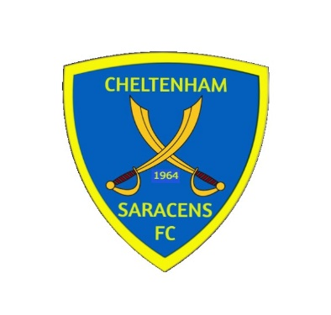
CHELTENHAM SARACENS FOOTBALL CLUB

Club History

Formed in 1964 as part of a multi-sport club, they joined the Cheltenham League Division 5. Gradually the football section grew in strength and was soon running two sides in the Cheltenham League, two in the Stroud & District, two Sunday teams and several youth teams.

In 1986 the club were elected to the Hellenic League and stayed in Division 1 until they were promoted to the Premier Division in 1999/2000 with the second team also winning the Reserve Section that same year. After two years in the Premier division the team were relegated back to Division 1 in 2001/2002.

In 2015/2016 the club narrowly missed out on winning the division 1 title but secured promotion to the premier division by finishing second, however the club decided to remain in division 1.

The club has now a strong base to move forward with three senior teams on Saturdays, a ladies team and junior teams aged between 6-14.

Club Honours

GFA Primary Challenge Cup Winner 1971/1972

Minor Charity Cup Winner 1990/1991

Cheltenham League Division 5 Winner 1990/1991

GFA Senior Amateur Cup Winner 1991/1992

Hellenic League Division 1 Winner 1999/2000

Hellenic League Reserve Section Winner 1999/2000

Hellenic League Division 1 Runners up 2015/2016

